Getting Started on the Assessment
Creating the System Specification

IMAT2207 Start Here 1
What next? 2
Before you Begin 3
Getting Started 3
Creating the System Specification 3
Creating the Individual Specifications 6
Teamwork v Group Work 7
Some Tips for Creating the Specification Document 7
When do we Delete Data? 11
What are Your Business Rules? 12
Creating the Individual Table Designs 13
Some Thoughts on How to do well 13
Communication 13
Documentation 14
Work Practices 14
Scrum Development 14
Product Backlog 14
Scrum Master 15
Sprint 15
Pair Programming 15
The Git Hub Day 15

IMAT2207 Start Here
In order to complete the work for this module you will be required to work in teams of 3-5 people.
For this first session you need to organise yourselves into your teams, decide on a team name, select a topic for your system and set up your team meeting room on MS Teams.
- You will need to access the team spreadsheet for your online workshop available here…
https://demontfortuniversity-my.sharepoint.com/:f:/g/personal/mdean00_dmu_ac_uk/Eh2aQ1SAdptCqb6TZz3x9D8B9oVYawjeqr6LiG87JLuFXQ?e=noV06B
Sign in with your DMU account and you should see something like the following…
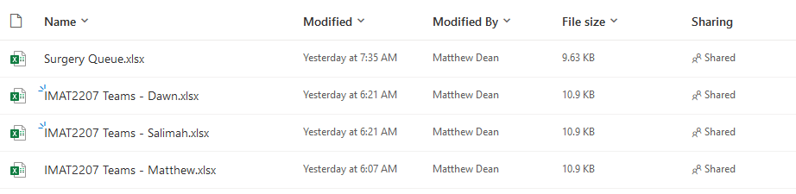
Open the spreadsheet belonging to your tutor and you should see something like this…
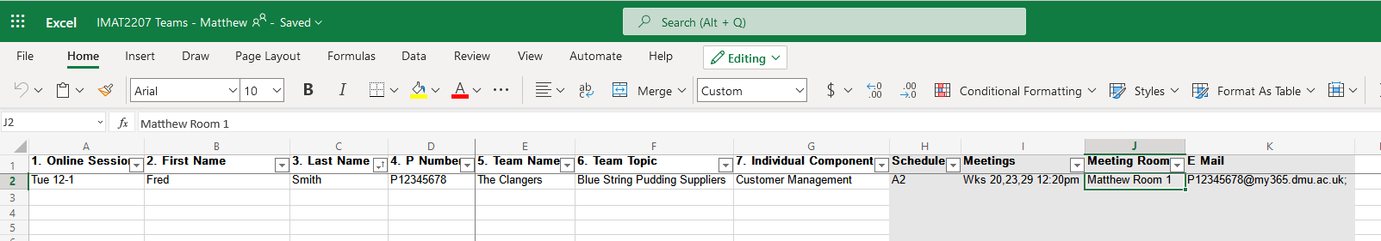
In the timetabled workshop you will need to add your details to the spreadsheet.
Once everybody is added your tutor will filter the list, that way you are able to see who is in the same workshop as you.
Use whatever communication tools you have available to see if you are able to form a team with the people you would like to work with (email addresses are visible in column K).
Once you have decided who you are working with you need to decide on a team name. This may be anything you like. Once you are happy enter this for each team member in column E.
Once everybody has a team name on the spreadsheet your tutor will update columns A with the date and time of this workshop so that they know when you are all due to attend.
Over the next week or so your team will be allocated to an assessment schedule.

What next?
Start working through the rest of this document.
Once you have decided on a topic for your system and allocated individual subsystems you will need to enter these on the spreadsheet.
For the rest of the work you and your team must complete the rest of this getting started document.

Before you Begin
Watch the following eLectures…
- Module Introduction
- Assessment Overview
- Claiming your eGrid
- Getting Help

Getting Started
To get started on the system we are going to put together a System Specification. The System Specification will consist of a written document stating what the system as a whole will do and who is working on what sub section.
By the end of this process each team member needs to have identified one significant table each and drawn up an initial set of attributes for that table.
There will be three sections to the system specification...
- The System Overview
- Individual Specifications
- Individual Table Schema
The above sections need to be assembled as a single word document and submitted as your first Friday journal entry.
Each team member needs to submit an identical copy of the system specification.

Creating the System Specification
For this module you need to think of a system that meets some sort of business requirement, typically selling stuff or providing a service.
As a team ask yourselves, what your system is going to do?
The answer to this question will inform the System Overview.
You are best to use OneDrive and screen sharing in MS Teams to create a shared version of this document.
Create a blank word document for the whole team and define what your system will do starting with a single sentence, for example...
“Our system will sell widgets”
This is the Core Functionality Definition. It defines the system in a single short sentence and is a good way of really tightening the focus of the system. If you cannot state this as a brief sentence, then your definition is likely too vague.
Once you have the Core Functionality defined you need to expand the idea into a paragraph or two of descriptive text...
This program will sell widgets to the general public. They will have access to a web based front end allowing them to browse and filter the available stock of widgets. There will be options for the customer to place widgets into a shopping cart and create an order. Upon creation of an order there will be a requirement that they create an account where they specify their personal details along with security and payment data. There will also be facilities for them to review and modify orders.
In addition to a customer facing front end there will also be a staff facing back end. Once an order is created by the customer it will be added to a list of orders for processing at the back end. The back end will allow for a range of admin functions such as managing customer data, staff data, stock and running various reports on data stored in the system e.g. orders placed.
Do not worry about over-specifying your system functionality, you will only be required to complete part of the full system requirements.
Potentially not all aspects of the system will be completed by the end of the project; this is fine as we lack both time and people to take the full system to completion.
Once you have an idea of what the system will do you need to identify who is taking on which section of the system development.
In this example the development team consists of four people, Rod, Jane, Freddie and Bungle.
For the assessment each team member must complete the full range of documents for their allocated section. Each team member is also responsible for all layers of their component, interface, middle layer classes and database components.
Remember this is team work not group work.
Each member stands or falls on the work that they themselves develop.
In this team we will allocate the following components to each team member...
- Rod Staff management system
Allowing adding, editing, deleting, listing and filtering of staff records
- Jane Customer management system
Allowing adding, editing, deleting, listing and filtering of customer data
- Freddie Stock management system
Allowing for maintenance of stock data, add, edit etc..
- Bungle Order processing
Allowing for customers to input an order and for staff to process that order to dispatch
Here is a rough guide. Allocating a single table to each team member should mean in each member will have a similar amount of work to do.
For example, take a look at the following initial ERD...
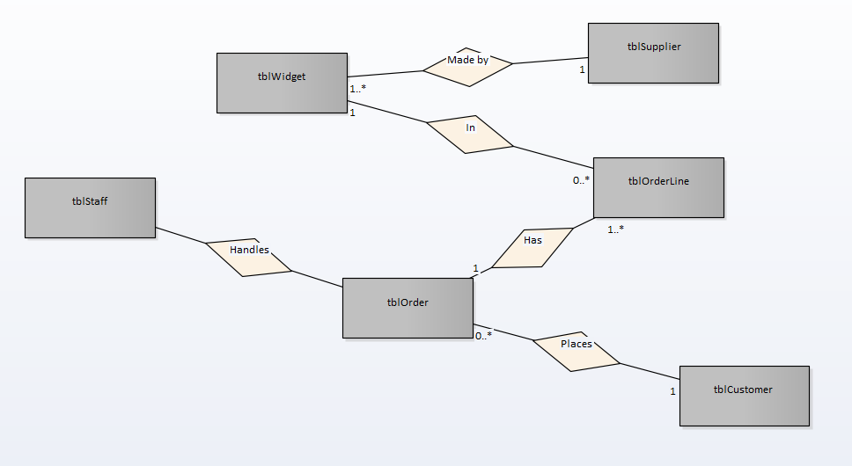
(You do not need to create an ERD at this stage but having a rough draft might help clarify the subcomponents in the larger system!)
Each table here is a potential unit of work for one person. Keep in mind that if somebody takes on order processing that it makes sense to write classes for order-line too!
This should give you a single document along the following lines (clearly more work is needed here) ...

Perfect Widget LTD

Est. 2019
Core Functionality: A System for Selling Widgets
Team Members: Rod
Jane
Freddie
Bungle
System Overview:
This program will sell widgets to the general public. They will have access to a web based front end allowing them to browse and filter the available stock of widgets. There will be options for the customer to place widgets into a shopping cart and create an order. Upon creation of an order there will be a requirement that they create an account where they specify their personal details along with security and payment data. There will also be facilities for them to review and modify orders.
In addition to a customer facing front end there will also be a staff facing back end. Once an order is created by the customer it will be added to a list of orders for processing at the back end. The back end will allow for a range of admin functions such as managing customer data, staff data, stock and running various reports on data stored in the system e.g. orders placed.

Try to think of yourselves no longer as students but as a company producing stuff. Think of a name for your company; why not come up with a logo?

Creating the Individual Specifications
Now that the team has created and agreed upon the System Overview, each team member is responsible for developing the detail related to their specific allocated component.

Teamwork v Group Work
You are most welcome to help and support each other in this task but resist the urge to do the work for another person.
You are marked individually remember!
If you complete the work for a team member who does nothing, they will be awarded the marks based on your hard work, which isn’t fair.
If a team member is not pulling their weight during the module, that is their problem. So long as you complete your allocated section you will still have access to the full range of available marks.

Some Tips for Creating the Specification Document
One common problem with individual specifications is that they are often too vague to really tell us what is going on.
Although it isn’t necessary to produce a formal role-play it is a good idea to try and imagine oneself in the situation of the potential user.
- Who is using the system?
- What will each actor do?
- When will they be performing these actions?
- Where will they be carrying out these use-cases?
- Why do they need to use the system?

(If you are not clear on any of these points then you must return to the client and find out, or in our case discuss the matter with your tutor.)
Also think about the typical tasks that any system must cater for...
- Add
- Edit
- Delete
- List
- Filter
- Find
- Validate
Ok – let’s set the scene.
Looking at the team we have the following members allocated with the following tasks...
- Rod Staff management system
Allowing adding, editing, deleting, listing and filtering of staff records
- Jane Customer management system
Allowing adding, editing, deleting, listing and filtering of customer data
- Freddie Stock management system
Allowing for maintenance of stock data, add, edit etc...
- Bungle Order processing
Allowing for customers to input an order and for staff to process that order to dispatch
Jane has taken on the task of developing the customer management system.
It is worth keeping in mind that each part of the system has a customer facing front end and a staff facing back end.
Perhaps when Jane has a first stab at expanding the details, they might look like this...
A customer visits the web site to buy some widgets. They go through the main log-in page and then start to browse the list of available widgets. Upon finding out that they are not a customer they follow the sign-up process entering their details and selecting a username and password. Once they see widgets that they need by browsing the stock list they add them in turn to the shopping cart. Once they have completed this process they proceed to check out and complete the order. Customers have the option to modify their personal data and close their account.
On the back end of the system staff process the order placed by the customer. They also have the option to manage the data for customers (add, edit delete) and run reports on customers.
As a first stab it isn’t bad. (Don’t worry about getting it perfect on the first attempt.)
It is a good idea to sit back and think about if this makes sense or not.
First off there seems to be some overlap between Jane’s customer system and Bungle’s order processing.
Who does the shopping cart functionality belong to? Is it Jane or Bungle?
As a rule, it is not a good policy to start writing system components that somebody else is getting paid for!
There is also another more subtle question to ask here?
Is the customer functionality intended to treat customers as actors or as entities (i.e. units of data)?
What does that mean?
Consider the following use case diagram...
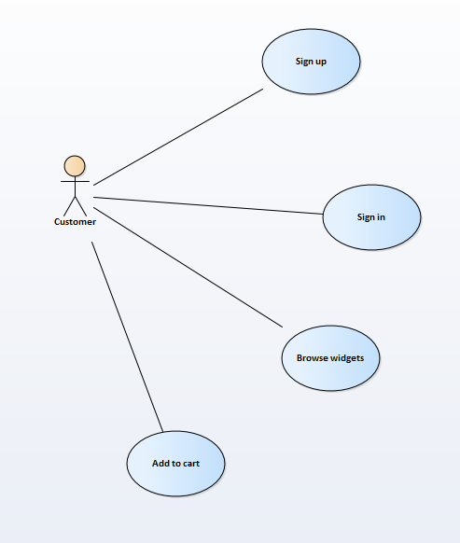
Here we are looking at what the customer does to the system as an actor.
This is the view Jane has but unfortunately Jane has the wrong idea here.
It isn’t what the customer does to the system as an actor that matters to Jane; it is what actors do to customer data within the system that really matters.
For example, ...
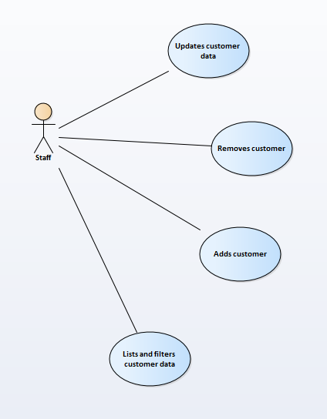
For Jane it is the management of customer data that is important.
The confusion comes about because “customer” is both data and actor in that they may manage their own data (but not data belonging to other customers)
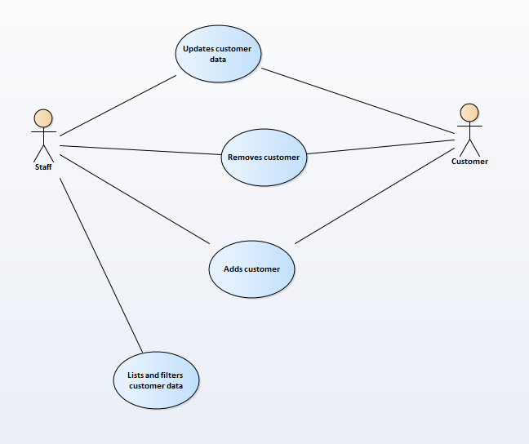
Taking into consideration these issues Jane needs to review her written description which results in shopping cart functionality dropping off her list...
A customer visits the web site to buy some widgets. They have the option to add themselves as a customer to the system and edit their details. Also, they can cancel their account on-line. Upon finding out that they are not a customer they follow the sign-up process entering their details and selecting a username and password.
On the back end of the system staff have the option to manage the data for all customers (add, edit delete) and run reports on customers.
There are also question here about when do we get to delete customer data?

When do we Delete Data?
Deleting a customer is a potential big deal because as a company we want to hold onto their data for as long as possible, also deleting customer data has the potential to break our database as we could generate orders with no associated customer record. Under law (GDPR) if a customer requests to be removed from the system we likely will have no choice but to do so (or at least anonymise their data).

What are Your Business Rules?
There are also questions here about who gets to add customers to the system. In many web sites customers sign themselves up on-line.
If I want to become an Amazon customer there is no option for me to ring up Amazon HQ and ask one of their members of staff to do it for me.
In other businesses the rules for adding customers are different. In a University system, students are added solely at the back end and never sign up online via the front-end.
These are all questions that you need to think about and address as you start to understand what your allocated section of the system is supposed to do.
Once the Individual Specification is complete you end up with a new document along the following lines...

Perfect Widget LTD
Est. 2019
Allocated Component: Customer Management System
Developer: Jane
Overview:
A customer visits the web site to buy some widgets. They have the option to add themselves as a customer to the system and edit their details. Also, they can cancel their account on-line. Upon finding out that they are not a customer they follow the sign-up process entering their details and selecting a username and password.
On the back end of the system staff have the option to manage the data for all customers (add, edit delete) and run reports on customers.

As before there is more work to be done with this document and each team member needs to have their own version of this document detailing what their allocated component is going to do.
Once completed this needs to be compiled into a single document for the team.

Creating the Individual Table Designs
Lastly each person must draw up an individual table design with a set of proposed attributes for their section of the system.
For example, if you are working on widget, your table design might look something like this...
tblWidget
WidgetNo Int Primary Key
WidgetDescription Text
WidgetColour Text
DateAdded Date
Price Decimal
Available Boolean
Your table design needs to include at least one example of the data types integer, string, date and Boolean. Do not create more than around six attributes including the primary key.

Some Thoughts on How to do well

Communication
Communication is by far THE most important issue to address in working as a team.
You need to appreciate that when you make a change to a section of the system you are not changing something that is owned just by you but is owned collectively by the entire team.
Break the code that belongs to you and you potentially break the code that belongs to the team!
There are number of approaches to improving communication.
- Have regular meetings with the team
- Be aware of the members of the team your changes will impact on
- Establish work practices that allow team members to know who is doing what when
- Use documentation to communicate your ideas in a clear and concise manner

Documentation
Over the course of this module we will look at range of documentary artefacts that allow us to think about how the system is going to work, but more importantly leave a paper trail of how we think the system is going to work.
- Individual Use Case Diagrams
- Individual Use Case Descriptions
- Team Class Diagrams
- Team Entity Relationship Diagrams

Be clear this only scratches the surface of the documents potentially available in the real world.
The documentation needs to be clear and concise and more importantly it needs to be aligned with reality at all points.
For example, …
- The class diagram needs to match the classes built within the system
- The use cases need to be aligned with the way that the system works
- The ERD should reflect the organisation of the tables in the database

If there is a lack of alignment, then it is a bit like trying to use a maps application with out of date map data.

Work Practices
For this module we will be adopting many of the practices of Agile/Extreme Programming (XP).

Scrum Development
Scrum development is a modern approach to developing systems that works on the assumption that our understanding of the system will change as we build it. There are two main reasons for this...
- Our perceptions change as we better understand the problem
- The customer’s requirements change as they see what is possible
There are certain practices and roles in this process.

Product Backlog
The product backlog is a to-do list of what needs completing to deliver the system. Each member of the team needs to claim items off the backlog over the period of development.
In the case of scrum team members may be allocated dynamically to functions. Somebody may work on a function for a limited time and then be switched to another function based on specialism.
Items on the product backlog should be ordered by priority. The team needs to focus on high priority functionality first moving to less important system functions.

Scrum Master
In a SCRUM team somebody takes charge of the process to make sure that it is being implemented properly. They will also need to take charge of the product backlog.

Sprint
A sprint is a time period where the team gets on with its agreed tasks. A sprint starts with a sprint planning meeting. At the planning meeting the product backlog needs to be reviewed and tasks allocated to the members of the team. After the two-week sprint the team will review the work completed so far. This review process will involve reviewing the Product Backlog. Removing functions that are completed and reviewing the list ensuring it matches user requirements. During the sprint the team must communicate and record the meetings.

Pair Programming
Pair programming is a practice where two programmers work on a task together.
One person in the pair takes the role of the code writer and the other takes the role of a code thinker.
Pair programming helps to spread the programming skill through the team.
Programming Pairs are again dynamically allocated over the lifetime of the project. Programmers do not typically pair permanently with the same person and pairs alternate the role of programmer and thinker.

The Git Hub Day
Finally, the lab work for the module although organized in weeks for the module represent Git Hub days.
As you work on the system your team will be using a tool called Git Hub that will house your shared code in the cloud.
A Git Hub day is a unit of work with a beginning middle and end where each developer works on the shared system individually working in a safe development space called a branch.
We will look at Git Hub in more detail as the module unfolds but a Git Hub day looks something like this…
Beginning A clone is made of the master repository and a new branch is made so that work may be carried out by the developer
Middle The developer carries out some work on the system in their branch. A section of work is completed, all tests for that section are passing and there are no compilation errors.
End The code for the branch is merged back into the main system and the branch is deleted.
A Git Hub day may range from an hour or two, to a couple of days. Remember 48 hours is a very long time in Git Hub!

